**DNS Record  Creation using Windows server 2012**

From the below mentioned record type, we are using **Address record[A RECORD]** for our organization. But I have mentioned all types of major DNS records. Its might be useful for future purpose.

## Basic DNS Record Types

There are a few different types of records that are primarily used for most of the devices on the Internet and inside company intranets. The following is a list of these primary record types:

* **Address (A) record –** This type of record is used to translate a domain name to a specific IPv4 address.
* **Address (AAAA) record –** This type of record is used to translate a domain name to a specific IPv6 address.
* **Canonical name (CNAME) record –** This type of record is used to specify a secondary name (commonly referred to as alias) for an existing A or AAAA record.
* **Mail Exchange (MX) record  –** This type of record is used to direct the mail communications for specific domains on the Internet. The record includes a priority and mail exchange agent domain name (this references an existing A, AAAA, or CNAME).
* **Start of Authority (SOA) record –** This type of record is typically configured with the creation of a zone and includes authoritative information about a specific domain name.
* **Name Server (NS) record –** This delegate the authoritative name servers for a specific domain, this record is also typically configured with the creation of the zone (in simple configurations).

## Basic DNS Record Set-up

This walkthrough is on Windows Server 2012, but similar steps can be taken on Windows Server 2008 R2. As a starting point, the Server Manager dashboard is used, but any method can be used to access the DNS Manager. Figure 1 below shows that the DNS Server role has been installed and can be selected from the left pane.

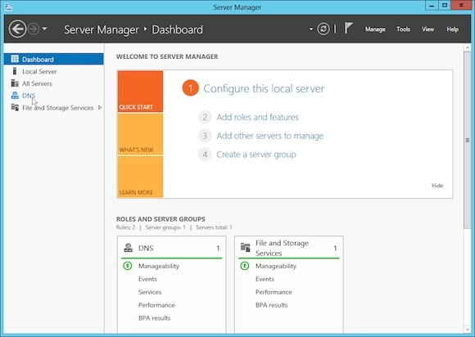

Once DNS has been selected, the available DNS servers will be displayed. Right-click on the target server and select **DNS Manager**, as shown in Figure 2 below.

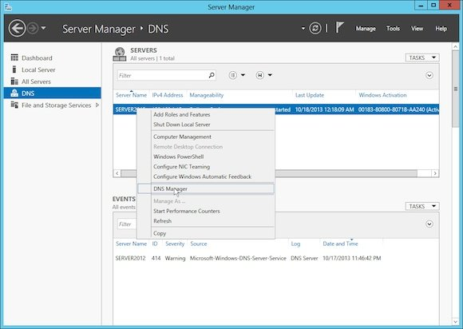

This will now bring up the DNS Manager. In the image below you can see that both a [forward and reverse lookup zone](https://petri.com/configure-forward-reverse-lookup-zones-in-windows-server-2008-r2-2012.htm) have been created.

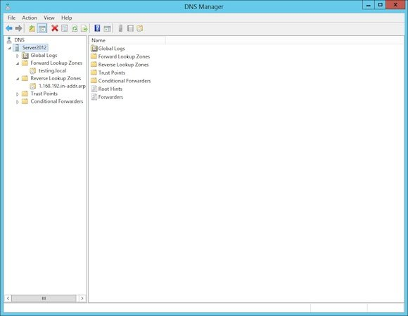

Choose the **forward lookup zone**, which will bring up a list of the existing zone records. Figure 4 below shows the basic records that are automatically created by the DNS configuration wizard. The first record that will be created is an **A record** linking the parent domain name (testing.local in this case) to the IPv4 address 192.168.1.100.

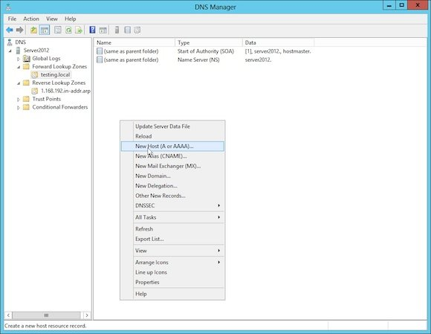

Right-click in the right pane and select **New Host (A or AAAA)**. This will bring up a window as shown below in Figure 5.

Now fill out the IP address textbox with the target address of *192.168.1.100*.

Click on the **Create associated pointer (PTR) record** and select **Add Host**.

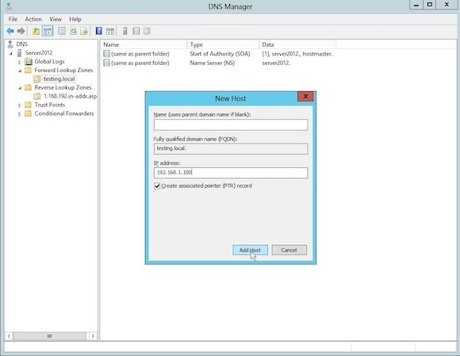

This will display the successful creation of the record. Select **OK** and bring back the Add Host window in case multiple records need to be created

Select **Close**. The screen will now show a new A record with the information that was entered.

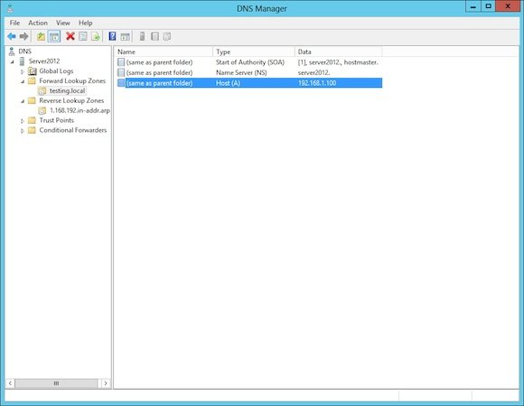

Click on the **reverse zone** that was previously created. Notice that a new PTR record now exists (as shown below in Figure 7).  This record will allow a reverse lookup of the 192.168.1.100 record to the testing.local domain name.

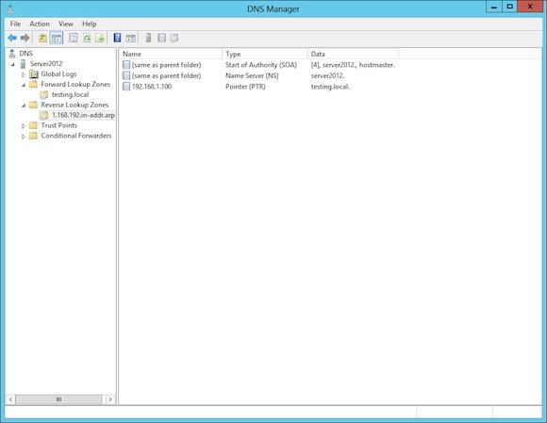

Select **Next**, this will bring back the main DNS Manager window (as shown in Figure 9) with a new CNAME record.

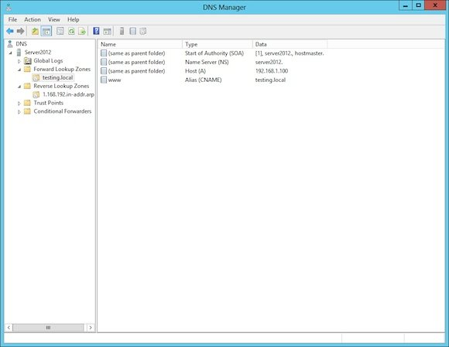

* The next record type that will be created is a **MX record**. Right-click on the right pane and select **New Mail Exchanger**, which will bring up the window shown in Figure 10. From this window the only thing that will be configured is the “Fully qualified domain name (FQDN) of mail server” textbox. This is because the mail being routed is for the whole testing.local domain and not specific sub-domains. The name that is placed in this textbox is the name of the mail server, in this case *mail.testing.local*. (An A record for mail.testing.local was added before this step but was not covered in the walkthrough).

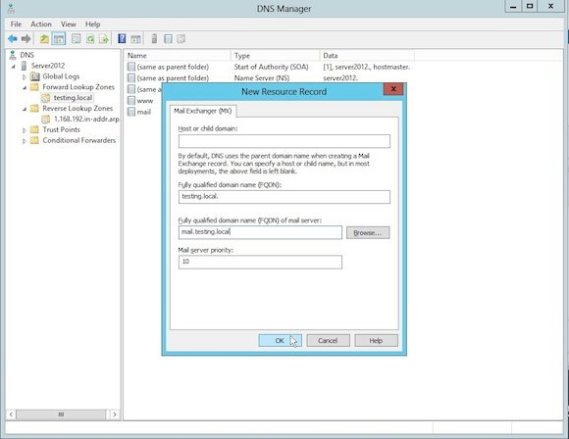

* Once complete, select **OK**. This will bring back the main DNS Manager window showing a new MX record.

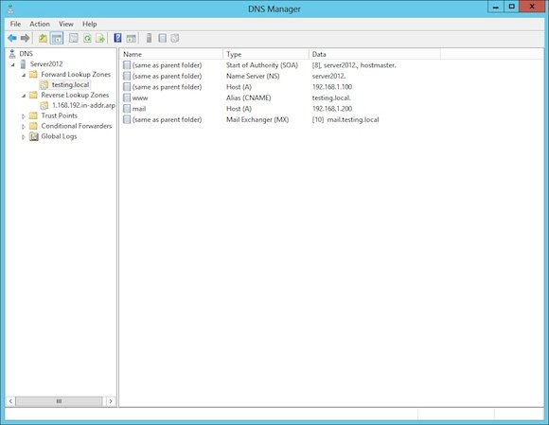

The last record that will be shown created is an **AAAA record**, which is like the A record but works with an IPv6 address instead of an IPv4 address.

* Right-click on the right pane and select **New Host (A or AAAA)**. This will bring up the window shown in Figure 12 (and Figure 5). In this window enter the IPv6 address *2001:DB8::1* to link to the parent domain name.

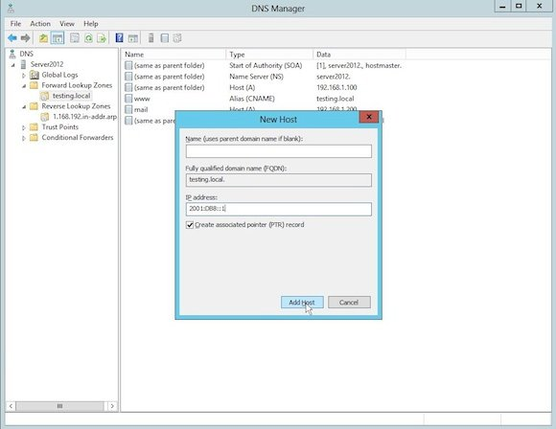

* Once complete select **Add Host**, then select **OK**.
* Select **Done** to get back to the main DNS Manager window shown below. This window shows that a new host record has been created using an IPv6 address.

